Create a linear regression model in R
- Define height and weight values:
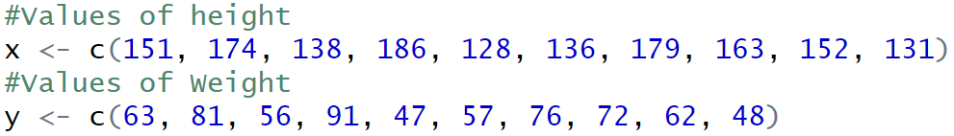
Here, two vectors, x and y, are defined to represent the height and weight values of individuals, respectively.

- Create a linear model (relation) for predicting weight based on height:
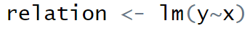
The lm() function in R is used to fit a linear model.
y ~ x specifies that y (weight) is the dependent variable, and x (height) is the independent variable.
The model relation now represents the linear regression equation for predicting y based on x.

- Print the linear model's details:
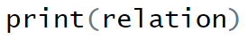
This displays the equation of the fitted linear model, which shows the intercept and slope of the line representing the relationship between height and weight.

- Generate a summary of the model:
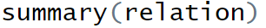
The summary() function provides detailed information about the model, including:
Coefficients of the model (intercept and slope),
R-squared value (which shows the proportion of variance explained by the model),
Statistical significance of the model and coefficients, helping us understand how well the model fits the data.
- Predict weight for a given height (170):
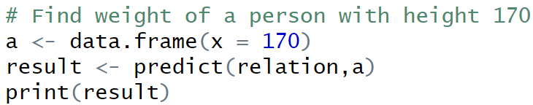

A new data frame a is created with x = 170, representing the height for which we want to predict weight.
predict(relation, a) uses the relation model to estimate the weight (y) for x = 170.
The predicted weight value for a height of 170 is then printed.

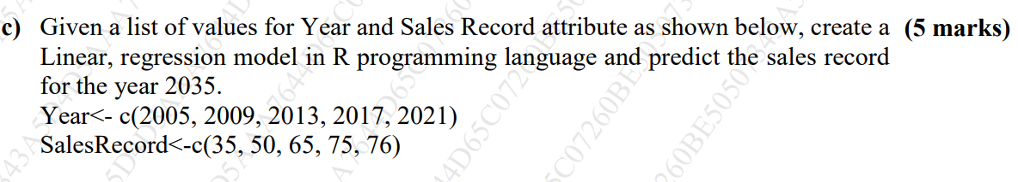
Question is solved using following steps
1. Define the Data:
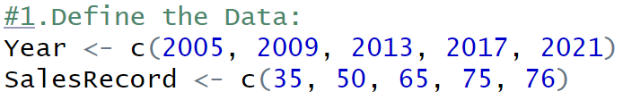
The Year vector represents the years for which sales records are available.
The SalesRecord vector contains the corresponding sales figures.
2. Create the Linear Model:
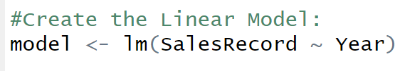
The lm() function fits a linear model where Sales Record is the dependent variable, and Year is the independent variable.
- Display Model Details:
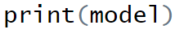
This shows the model's intercept and slope.
- Summarize the Model:
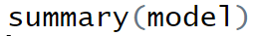
The summary() function provides additional statistics, such as R-squared and p-values, which help assess model accuracy.
- Predict Sales Record for 2035:
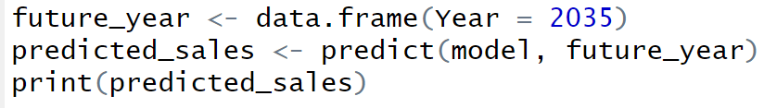
We create a new data frame with the Year set to 2035 and use the predict() function with the model to estimate the sales record for that year.

